**CHAPTER 2**

**SYSTEM DESIGN**

**2.1 SCHEMA DIAGRAM**

**2.1 SCH**

|  |  |  |
| --- | --- | --- |
| Id | Username | Password |

ADMIN

CATEGORIES

|  |  |  |
| --- | --- | --- |
| Id | Name | Description |

PRODUCT

|  |  |  |  |
| --- | --- | --- | --- |
| Id | Name | Price | Category |

BILL

|  |  |  |
| --- | --- | --- |
| Name | Price | Quantity |

**Fig 2.1.1: SCHEMA DIAGRAM**

**2.2 ER DIAGRAM**

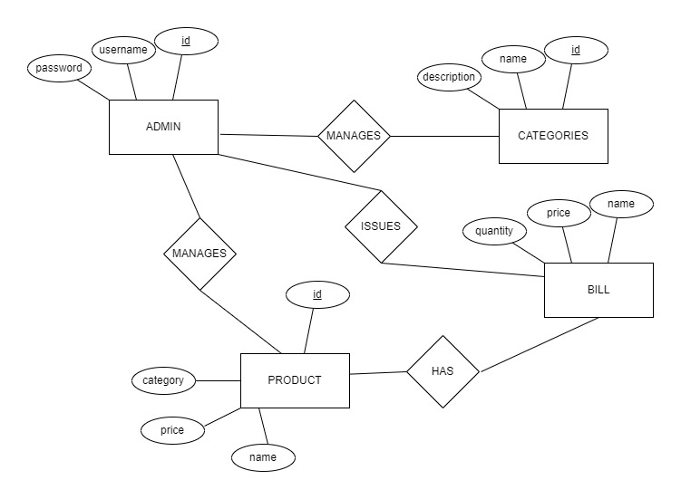

**Fig:2.2.1:ER DIAGRAM**